Working at Height – Sanitation & Social Distance

1.0 Purpose and Scope
Industrial Training Services Inc has been closely monitoring the COVID-19 situation in Ontario. Both the federal and provincial governments are making significant interventions in response to COVID-19 and these changes are in turn forcing businesses to rapidly adjust while trying to navigate the resulting financial and operational challenges.

Industrial Training Services Inc is here to help. We understand the importance of safety training for businesses during this time, especially when businesses are forced to run lean operations and having trained and skilled personnel is of utmost importance for business continuity.

To support businesses in this regard, Industrial Training Services Inc has commenced classroom training thanks to the persistent efforts of our team from April 28, 2020.

The following procedures are steps being taken to prevent the spread of the virus and protect office employees from getting the virus.

2.0 Definitions
Action Plan:
An action plan is a detailed plan outlining actions needed to reach one or more goals. Alternatively, business dictionary.com defines an action plan as a "sequence of steps that must be taken, or activities that must be performed well, for a strategy to succeed"

Covid-19:
The virus that is mainly transmitted through droplets generated when an infected person coughs, sneezes, or exhales. These droplets are too heavy to hang in the air, and quickly fall on floors or surfaces.

People can be infected by breathing in the virus if you are within close proximity of someone who has COVID-19, or by touching a contaminated surface and then your eyes, nose or mouth.

HR:
Human Resources Department.

PPE:
Personal protective equipment is protective clothing, self-supporting air helmets, goggles, face shield. N95 face mask and other equipment designed to protect the wearer's body from infection (COVID-19). The hazards addressed by protective equipment include physical, biohazards, and airborne particulate matter.

Pandemic:
All countries are at risk and need to prepare for and respond to COVID-19.
Each country is encouraged to plan its preparedness and response
actions in line with the global Strategic Preparedness and Response
Plan.

To facilitate the global planning process including the identification of the overall response envelope required, a preliminary categorization of countries was conducted based on:

- Operational readiness capacities based on the self-assessment.
- Current position on a continuum of response scenarios:
  - Preparedness,
  - High-risk of imported cases,
  - Imported cases,
  - Localized transmission,
  - Community transmission.

The operational readiness categorization was refined based on additional information from voluntary external evaluations, pandemic preparedness plans, country readiness assessment for health emergencies, missions to the countries, as well as the most up-to-date country specific COVID-19 situation analyses.

Epidemic:
An epidemic is a disease that spreads rapidly. Epidemics of infectious disease are generally caused by several factors including a change in the ecology of the host population (e.g. increased stress or increase in the density of a vector species), a genetic change in the pathogen reservoir or the introduction of an emerging pathogen to a host population (by movement of pathogen or host).

Generally, an epidemic occurs when host immunity to either an established pathogen or newly emerging novel pathogen is suddenly

reduced below that found in the endemic equilibrium and the transmission threshold is exceeded.

Social Distancing:
Social distancing aims to keep healthy people away from sick people in
an effort to slow down and prevent the spread of a contagious disease,
like COVID-19. It means limiting close contact with people and avoiding
large crowds and groups. It may sound inconvenient, but it's a social
responsibility we should all take seriously. (That and making sure you're
practicing proper hand hygiene and proper cough etiquette).

Even though some people experience only a mild illness when infected with the new coronavirus, others don't. Preventive measures like social distancing help protect vulnerable people from developing more serious illness. But social distancing also includes a conscious, individual effort from each one us to practice the measures that help prevent the spread
of COVID-19.

Proper Cough Etiquette:
To cover your cough the right way, follow these four steps:
- Grab a facial tissue. If you're going to be out and about, consider carrying travel packs of facial tissue with you.
- Move away from people around you. If you're in a crowded space, try to at least turn away from everyone.
- Cough into the tissue and throw the tissue in a trash can. You may want to consider carrying a disposable, sealable plastic bag with you in case you can't find a trash can.
- Wash your hands after. Consider carrying hand sanitizer in case soap and water are not available.
If you don't have access to facial tissue, you can cough into the crook of your elbow. Keep in mind, coughing into your hands should be your last resort, and be sure to wash your hands immediately afterwards. If not, you run the risk of spreading the virus as you touch surfaces.

In addition, if you're coughing a lot, consider staying home. The best way to help keep others from getting sick is to avoid bringing your cough out of your home in the first place.

Proper Hand Hygiene (Washing):
When it comes to when you should consider your hand hygiene, a few of the more obvious times probably to mind. But, just to make sure we're all on the same page, the most important times to wash your hands are:
- After using the bathroom
- Before eating food
- Before, during and after food preparation
- While caring for someone who is sick
- After diaper changing or cleaning up after a child
- After sneezing, coughing or blowing your nose
- After touching an animal, an animal's food (including treats) or an animal's waste
- After handling garbage

Temperature Testing:
Temperature screening alone, at entry, is one of an effective way to stop international spread, since infected individuals may be in incubation period, may express apparent symptoms early on in the course of the disease (COVID-19) and to collect health declarations upon arrival.

Vulnerable People:
As coronavirus cases continue to rise around the country, you've hopefully already familiarized yourself with symptoms to watch for (cough, fever and shortness of breath), as well as the ways to prevent the spread of COVID-19.

You've probably also heard that some people are at higher risk of developing a severe case of COVID-19, including:
- People over the age of 65
- Those with underlying chronic health conditions

As people age, their immune system weakens, making it much harder for them to fight infections. This is what makes the elderly more vulnerable to experiencing serious complications of COVID-19, including pneumonia and even death.

3.0 Responsibilities
The Human Resources Department has three main responsibilities regarding COVID-19:
- Receiving, screening, and preliminary analysis of disclosures of conditions.
- The Human Resources Manager must select, mandate and manage the COVID-19 prevention team.
- Reviewing daily data of the temperature test and pandemic questionnaire, and making recommendations to the President.

- Procedures
4.1 Posting:
  - A laminated poster will be posted at the front entrance and public bathroom.

  - A laminated poster will be posted in the training room and be left of the training table.

4.2 What is social Distancing:
4.2.1 Together, we can slow the spread of COVID-19 by making a conscious effort to keep a physical distance between each other. Physical distancing is proven to be one of the most effective ways to reduce the spread of illness during an outbreak. With patience and cooperation, we can all do our part.

4.3 What does physical distancing mean?
4.3.1 This means making changes in your everyday routines in order to minimize close contact with others, including:
- avoiding crowded places and gatherings
- avoiding common greetings, such as handshakes
- limiting contact with people at higher risk (e.g. older adults and those in poor health)
- keeping a distance of at least 2 arms lengths (approximately 2 metres) from others, as much as possible
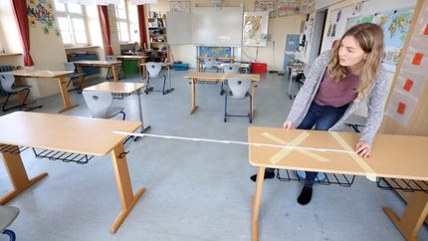

  - Prior to Training:
4.4.1 There will be a request by email or phone call to the client, that they are to bring their own lunch. Trainee will not be allowed to leave the training in order to get food. Bottled water will be available to trainees and/or coffee.

    - A request to the employer if they can provide PPE (Facemask, and/or gloves) for their workers.

  - Day of Training:
4.5.1 The trainer must wear his PPE (Face mask & Gloves) prior to going to the entrance to allow the workers.

4.5.2 At the entrance, the following questions will be asked:
- Have you traveled or had contact with someone that has traveled outside Canada within the last 14 days?
- Do you feel like you have any flu symptoms?
- Does anyone in your family have flu symptoms?
- Have you visited an old age home? And did you wear a facemask and gloves

    - If they answer “NO” to the above questions then they can sanitizer their hands and wear gloves.

    - Proceeding to the training room will use social distancing.

  - While Training:
4.6.1 The training room will be set-up to meet social distancing recommendations. A two (2) meter distance will be maintained within the training room.

4.6.2 Trainer will be at the front of the room and will maintain social distancing with the trainees.

4.6.3 All paperwork require for the training will be placed in the student spot.

4.6.4 Explanation of wrong answers on the exam will be present at the time of marking to the trainee. The trainer will not move to another location.

  - After Training:
    - All paperwork will be completed and left in the training room for at least one week.

    - Then all surfaces, supplies and equipment will need to be sanitized prior to the next training.

    - Wait 24 hours before you clean or disinfect. If 24 hours is not feasible, wait as long as possible.

4.8 What to Clean and how to clean:
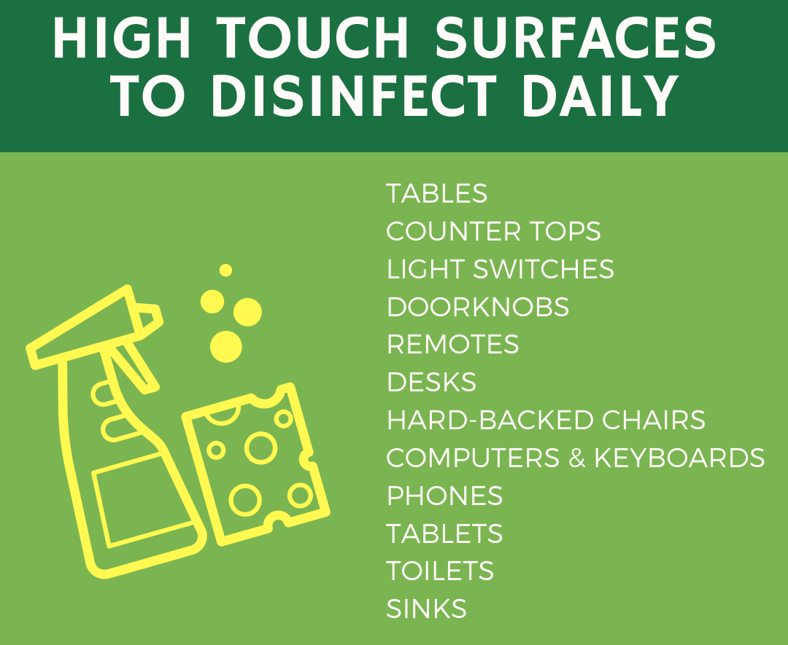

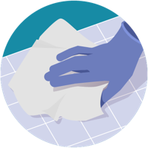

Clean:
- Clean surfaces using soap and water, then use disinfectant.
- Cleaning with soap and water reduces number of germs, dirt and impurities on the surface. Disinfecting kills germs on surfaces.
- Practice routine cleaning and disinfection of frequently touched surfaces.
  - More frequent cleaning and disinfection may be required based on level of use.
  - Surfaces and objects in public places, such as shopping carts and point of sale keypads should be cleaned and disinfected before each use.
High touch Surfaces Include:
Tables, doorknobs, light switches, countertops, handles, desks, phones, keyboards, toilets, faucets, sinks, etc.
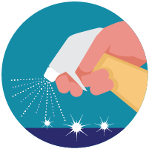

Disinfect:
- Recommend use of disinfectants used against COVID-19 with cleaning product that contains bleach, ammonium, or alcohol (Ethanol or Isoproanol) over 70%
- Follow the instructions on the label to ensure safe and effective use of the product.
Many products recommend:
  - Keeping surface wet for a period of time (see product label)
  - Precautions such as wearing gloves and making sure you have good ventilation during use of the product.
Diluted Household Bleach Solutions may also be used if appropriate for the surface.
Check the label to see if your bleach is intended for disinfection, and ensure the product is not past its expiration date. Some bleaches, such as those designed for safe use on colored clothing or for whitening may not be suitable for disinfection.
Unexpired household bleach will be effective against coronaviruses
when properly diluted.
Follow manufacturer’s instructions for application and proper ventilation. Never mix household bleach with ammonia or any other cleanser.

Leave solution on the surface for at least 1 minute.
To make a Bleach Solution Mix:
  - 5 tablespoons (1/3rd cup) bleach per gallon of water
OR
  - 4 teaspoons bleach per quart of water
- Bleach solutions will be effective for disinfection up to 24 hours.
- Alcohol solutions with at least 70% alcohol may also be used.

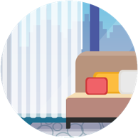

Soft surfaces:
For soft surfaces such as carpeted floor, rugs, and drapes
  - Clean the surface using soap and water
or with cleaners appropriate for use on these
surfaces.
      - Launder items (if possible) according to the manufacturer’s instructions. Use the warmest appropriate water setting and dry items completely.

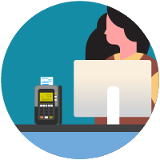

Electronics:
For electronics, such as tablets, touch screens, keyboards, remote controls, and another electronic device
- Consider putting a wipeable cover on electronics.
- Follow manufacturer’s instruction for cleaning and disinfecting.
  - If no guidance, use alcohol-based wipes or sprays containing at least 70% alcohol. Dry surface thoroughly.

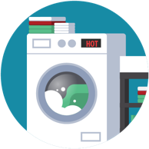

Laundry:
For clothing, towels, linens and other items
- Launder items according to the manufacturer’s
instructions. Use the warmest appropriate water
setting and dry items completely.
    - Wear disposable gloves when handling dirty laundry from a person who is sick.

    - Dirty laundry from a person who is sick can be washed with other people’s items.
    - Do not shake dirty laundry.
    - Clean and disinfect clothes hampers according to guidance above for surfaces.
    - Remove gloves, and wash hands right away.

4.9 Sanitation of Training Room:
Wait 24 hours before you clean or disinfect. If 24 hours is not feasible, wait as long as possible.

Items need cleaning:
    - Table top
    - Chairs
    - Pens
    - Floor
    - Door and door knob
    - Computer
    - Projector
    - Equipment used for practical (See section on cleaning equipment)

For cleaning, water and detergent (e.g., liquid dishwashing soap) or common household cleaning wipes should be used. Apply firm pressure while cleaning. Surfaces should be cleaned at least once a day. Next, use a store bought disinfectant or diluted bleach solution, one-part bleach to 50 parts water (20ml of bleach to 1 litre of water), and allow the surface to remain wet for one minute and dry with paper towels.

Clean surfaces that are touched often with sanitizer spray and paper towel

4.10 Cleaning Method:
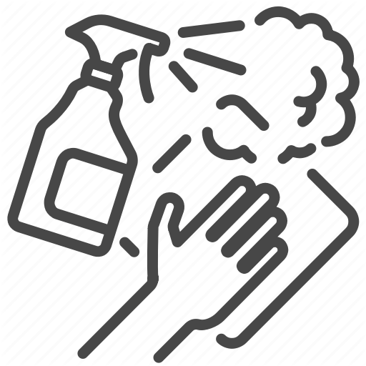

Sanitizer and paper towel

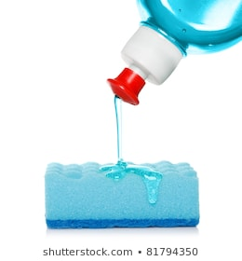

Using a sponge and mild solution of water and commercial soap or detergent

    - Fall Protection Equipment Sanitizing:

4.11.1 Storage Container:
Clean the outside of bucket, handle, and lid with sanitizer spray.
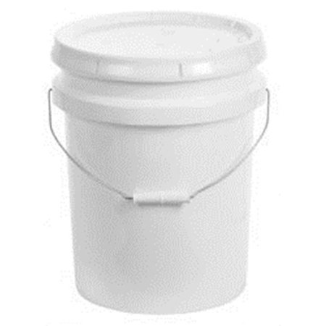

    - Full Body Harness:
Using a sponge and mild solution of water and commercial soap or detergent, to remove any dirt, corrosives, or contaminants. Hang freely to dry, but away from excessive heat, steam, or long periods of sunlight.

For Webbing:
Use soap and sponge

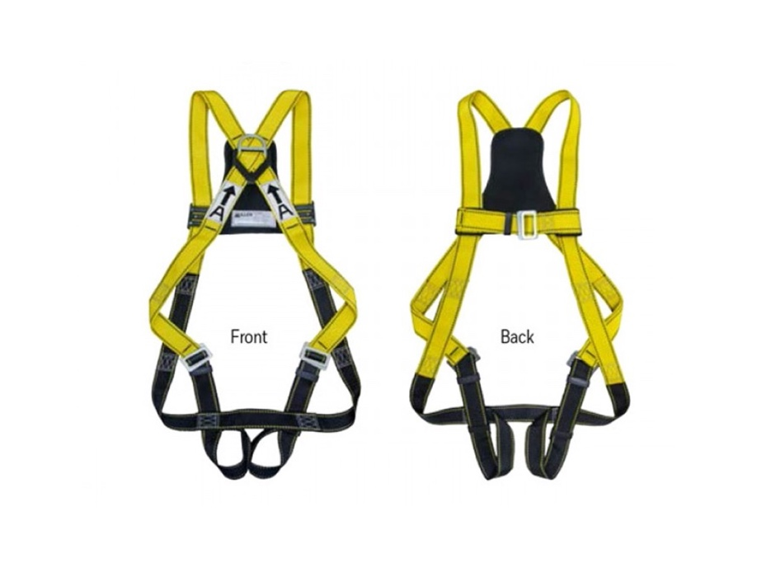
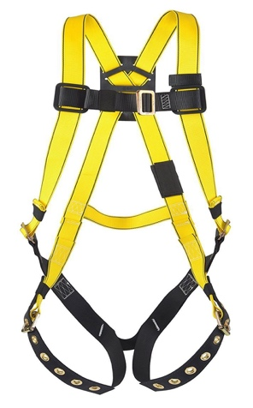
For all metal and plastic components:
Spray sanitizer on paper towel and clean – do not spray sanitizer directly on equipment.

    - Lanyard:
Using a sponge and mild solution of water and commercial soap or detergent, to remove any dirt, corrosives, or contaminants. Hang freely to dry, but away from excessive heat, steam, or long periods of sunlight.

For Webbing:
Use soap and sponge

For all Metal and Plastic Components:
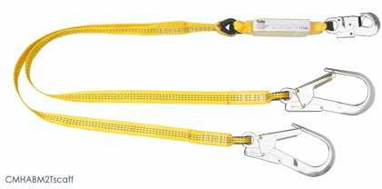
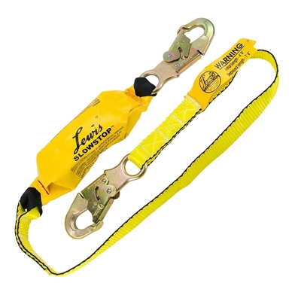
Spray sanitizer on paper towel and clean – do not spray sanitizer directly on equipment.

    - Rope Grab:
Spray with sanitizing spray and wipe dry with paper towel. Make sure to wipe all solution off equipment before storing it.

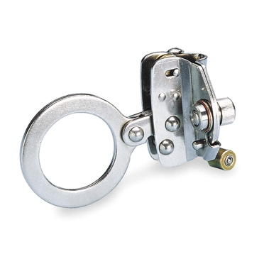

    - Lifeline:
Using a sponge and mild solution of water and commercial soap or detergent, to remove any dirt, corrosives, or contaminants. Hang freely to dry, but away from excessive heat, steam, or long periods of sunlight.

For Webbing:
Use soap and sponge

For all Metal and Plastic Components:
Spray sanitizer on paper towel and clean – do not spray sanitizer directly on equipment
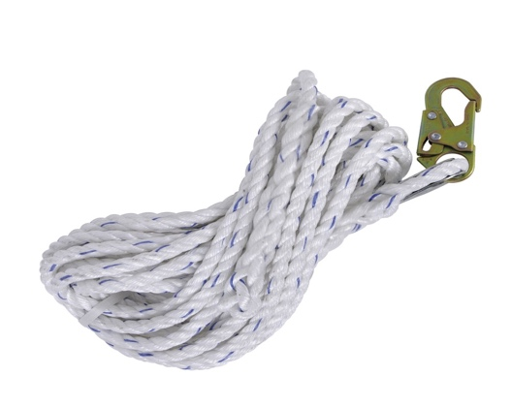

    - D-Ring:
Spray with sanitizing spray and wipe dry with paper towel. Make sure to wipe all solution off equipment before storing it.

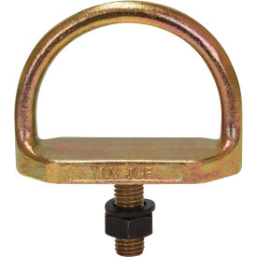

    - Carabineer
Spray with sanitizing spray and wipe dry with paper towel. Make sure to wipe all solution off equipment before storing it.
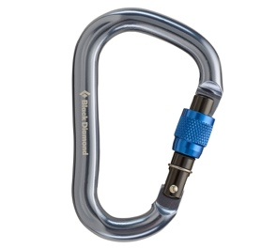
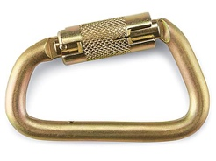

    - Damage Equipment:
See specific equipment cleaning above.

    - Material Face Masks:
These masks are made from surgical grade fabric (polyester poplin).

After every use don’t forget to wash and iron with steam (no less than the 2nd ironing setting) to destroy the bacteria that might have collected on the mask!

4.12 Sanitation of Public Bathroom:
Wait 24 hours before you clean or disinfect. If 24 hours is not feasible, wait as long as possible.

Items need cleaning:
    - Sink
    - Faucet
    - Countertop
    - Vanity
    - Toilet
    - Floor
    - Soap dispenser
    - Door and door knob

For cleaning, water and detergent (e.g., liquid dishwashing soap) or common household cleaning wipes should be used. Apply firm pressure while cleaning. Surfaces should be cleaned at least once a day. Next, use a store bought disinfectant or diluted bleach solution, one-part bleach to 50 parts water (20ml of bleach to 1 litre of water), and allow the surface to remain wet for one minute and dry with paper towels.

Clean surfaces that are touched often with sanitizer spray and paper towel

4.13 Sanitation of Pathway to Training Room:
Wait 24 hours before you clean or disinfect. If 24 hours is not feasible, wait as long as possible.

Items need cleaning:
    - Walls
    - Stair Rail
    - Light switch
    - Stairlift
    - Door
    - Door knob

For cleaning, water and detergent (e.g., liquid dishwashing soap) or common household cleaning wipes should be used. Apply firm pressure while cleaning. Surfaces should be cleaned at least once a day. Next, use a store bought disinfectant or diluted bleach solution, one-part bleach to 50 parts water (20ml of bleach to 1 litre of water), and allow the surface to remain wet for one minute and dry with paper towels.

Clean surfaces that are touched often with sanitizer spray and paper towel

4.14 Front Entrance:
Wait 24 hours before you clean or disinfect. If 24 hours is not feasible, wait as long as possible.

Items need cleaning:
    - Door surface (inside and outside)
    - Door handle (Inside and outside)
    - Floor
    - Vacuum carpets

For cleaning, water and detergent (e.g., liquid dishwashing soap) or common household cleaning wipes should be used. Apply firm pressure while cleaning. Surfaces should be cleaned at least once a day. Next, use a store bought disinfectant or diluted bleach solution, one-part bleach to 50 parts water (20ml of bleach to 1 litre of water), and allow the surface to remain wet for one minute and dry with paper towels.

Clean surfaces that are touched often with sanitizer spray and paper towel

5.0 References
5.1 Related Procedures
QP 09 02 Operator Instructions
QP 18 01 Training

5.2 Reference Documents
Employees Handbook
ISO9001:2015 Standard

6.0 Records
QF-09 Training Record
QF-54 Training Plan
QF-14 Employee Skill Training Record

6.1 Revision History
Date Revision Level Change
04/28/2020 1 Release

